 | Use show vlan brief on old switches to see VLAN IDs, names, and active ports.
S1 | 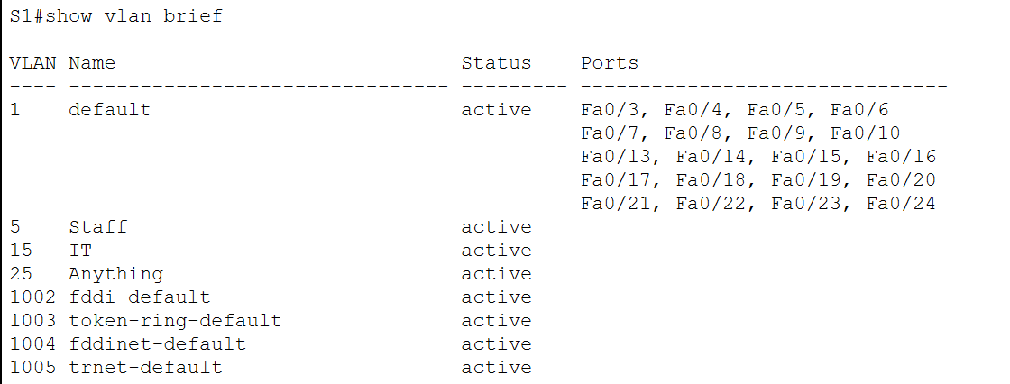
S2 | 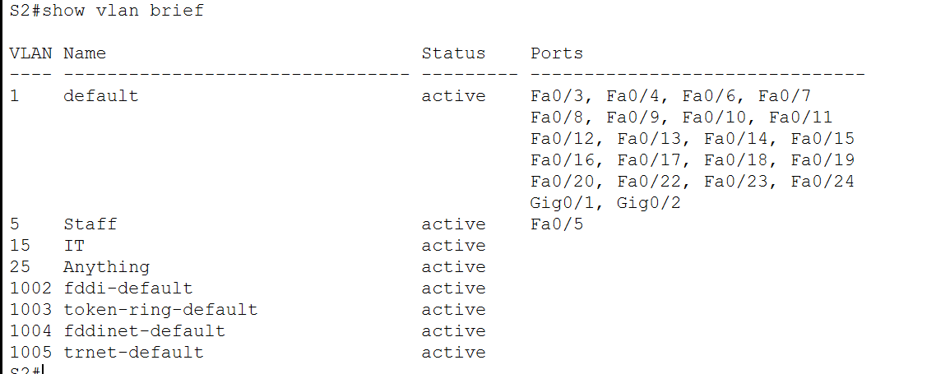
S3 | 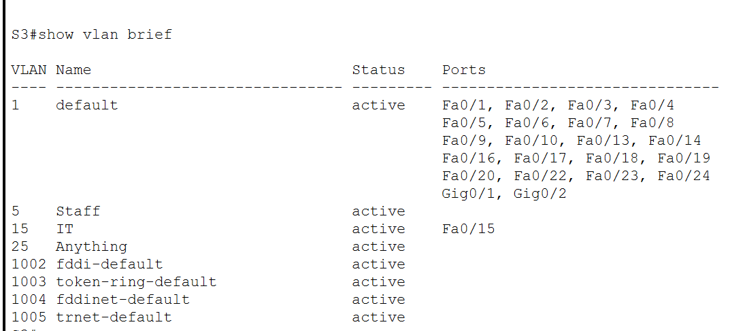

 | Use show interfaces trunk or show running-config to see trunk ports.
S1 | 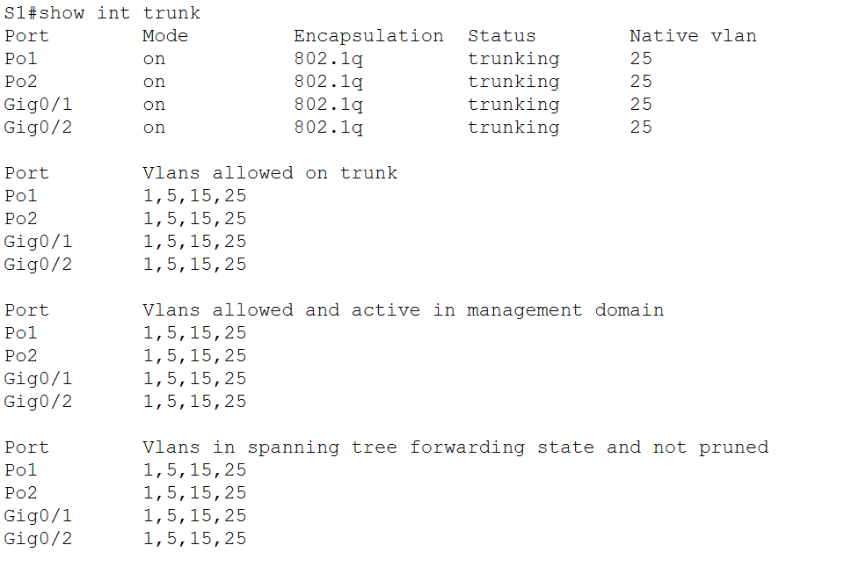
S2 | 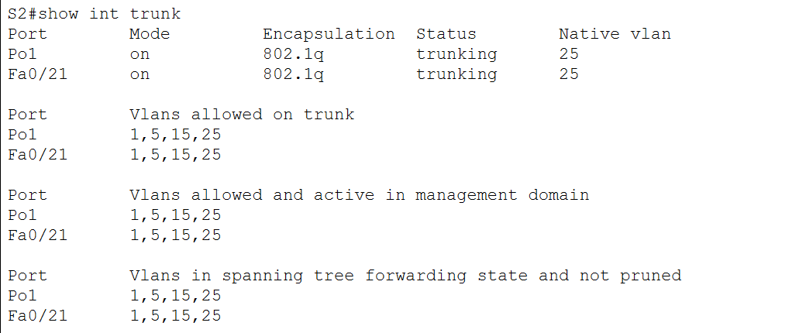
S3 | 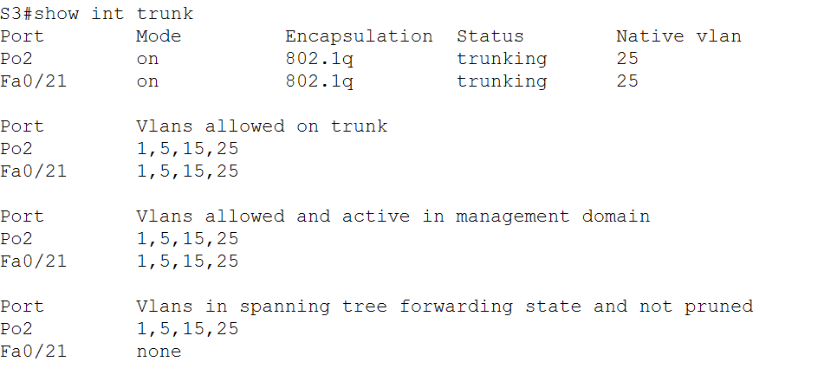

 | Use show etherchannel summary on old switches
S1 | 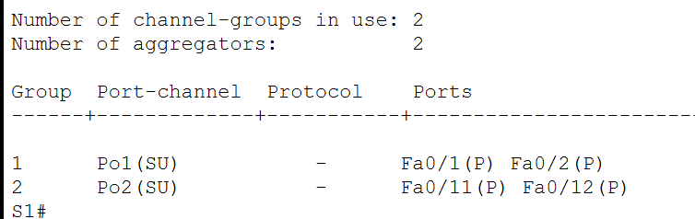
S2 | 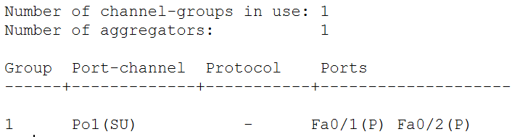
S3 | 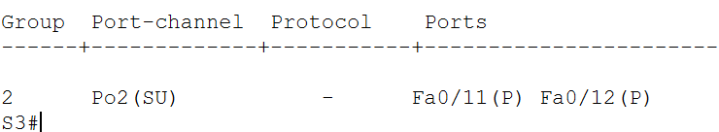

S1 | 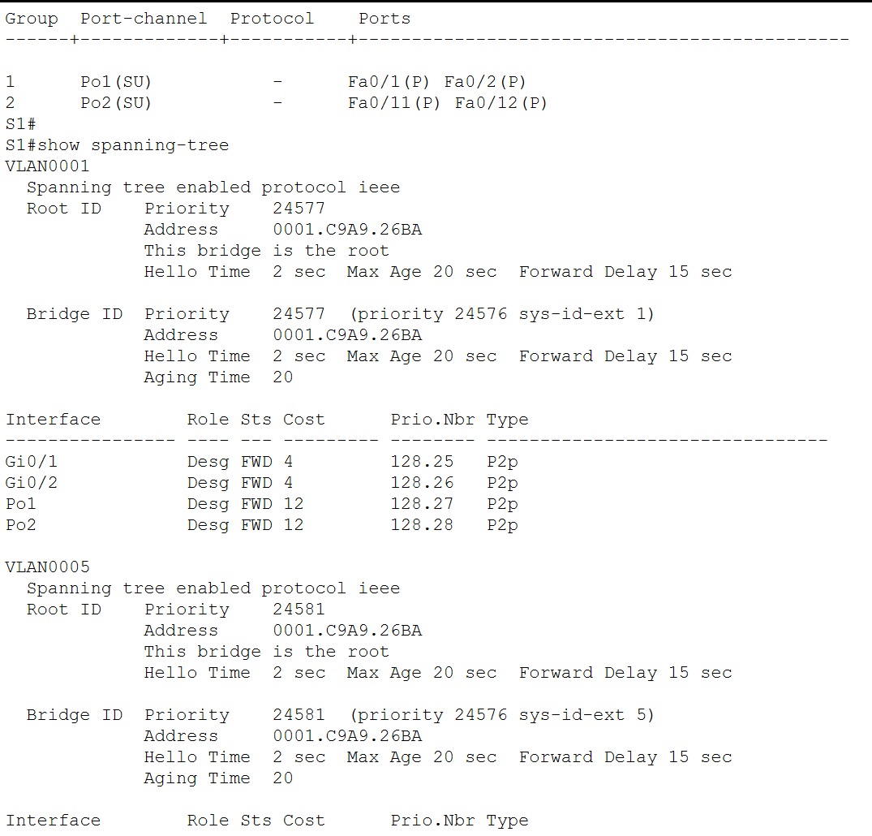  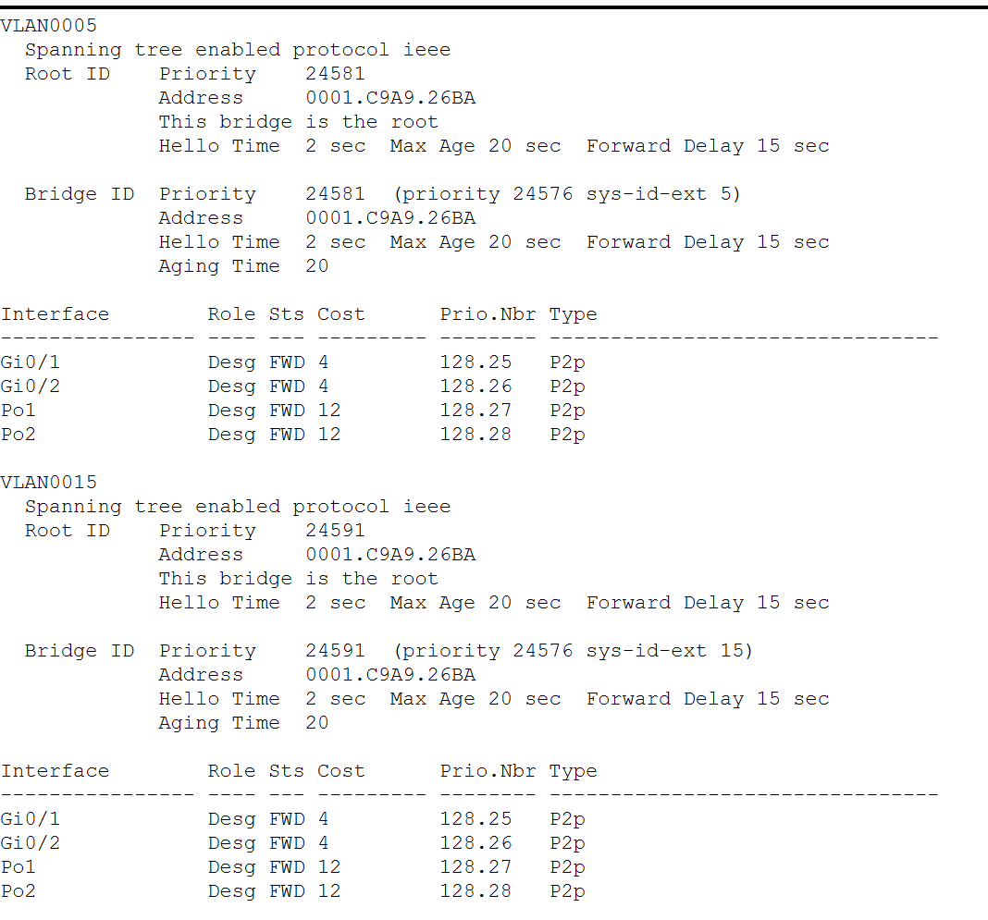  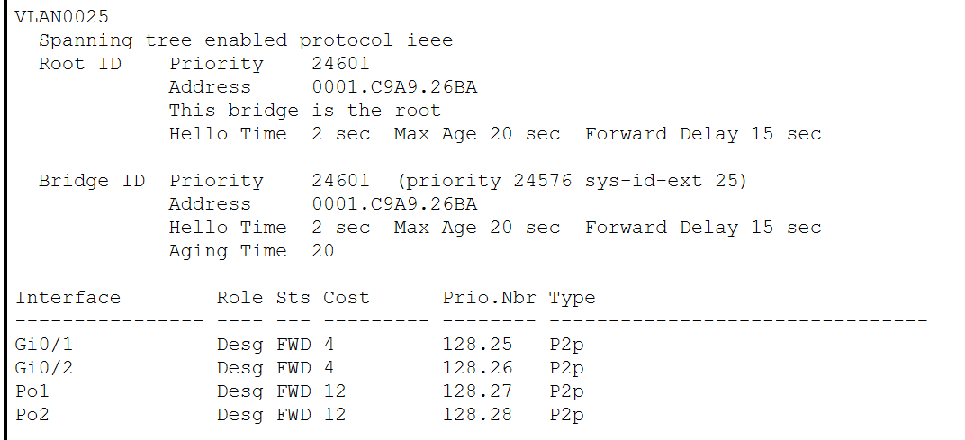

R1 | 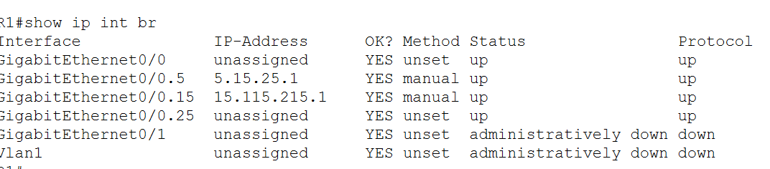
R2 | 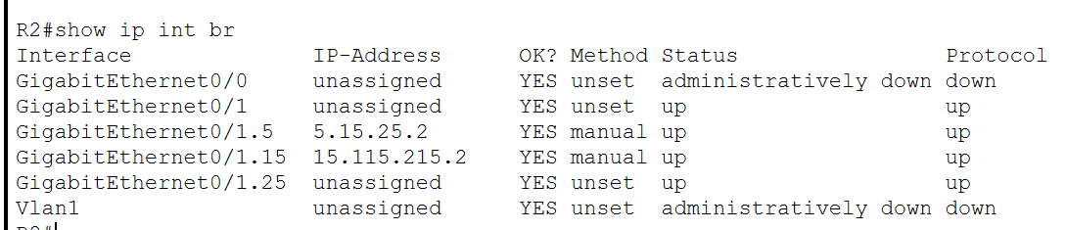

Configure vlan name all switch
conf t
vlan 5
name Staff
vlan 15
name IT
vlan 25
name Anything
exit

ACCESS PORTS (example — adjust per your table)
S2
interface fa0/5
switchport mode access
switchport access vlan 5
S3
interface fa0/15
switchport mode access
switchport access vlan 15

TRUNK LINKS
S1
interface range fa0/1 - 2
switchport mode trunk
switchport trunk allowed vlan 1,5,15,25

S2
interface range fa0/1 - 2
switchport mode trunk
switchport trunk allowed vlan 1,5,15,25

S3
interface range fa0/11 - 12
switchport mode trunk
switchport trunk allowed vlan 1,5,15,25

